**CAPCAFE**

TEAM MEMBER:

AKASH VERMA

HARSHITA GUPTA

**PROBLEM STATEMENT**

The online Food Ordering System is specifically designed for working Employees (Customers) at Capgemini to solve the common problem of waiting for long hours during their Lunch Break after the food is ordered. Sometimes, the employees sometimes also want to get a particular food item delivered from other cafeteria location of Capgemini. So the online food ordering system is designed so as to privilege Employees to pre order their food before Lunch which they can either pick up at their own cafeteria or get it delivered from some other cafeteria of Capgemini.

**DESCRIPTION**

The system sets up a food menu online across various Cafe Locations. The customers (users) can easily place the order as per they like by selecting any particular item from the selected Cafe. The Admin maintains all the Customer/Cafe database and monitors Help Desk to improve food delivery service. The system is designed to best monitor and improve the customer experience by providing the features like feedback and Help Desk. Customers also can check payment options while placing order. For more secure ordering, separate accounts are maintained for each user by providing them an ID and a password. Password is very securely hash-coded.

**SCOPE**

Using the online food ordering system, the user can view all the food items in menu under specified cafe. User can place his order, put them in the cart, view all his previous order and current order details, select payment option at time of payment or get his order Id through which he can raise tokens for helpdesk in order to resolve any complaints/ issues related to specific order and finally mark the token as resolved after his message has been resolved by the admin. User can also give/view reviews/ratings for any selected cafe/food item.

Using the online food ordering system, the admin can add cafes and food items in menu. He can also view all the order details after any customer places an order, view and redresses any raised token for any particular order. Admin can also view all reviews and ratings for all cafe and menu items.

**OUT OF SCOPE**

The system is developed solely for App users. Functionalities for Cafe owner is out of scope for the developed system. Tracking of placed orders, Mapping of customer address with their nearest cafe location is out of scope, Suggestions/Recommendations for customers based on customer ratings and previous orders, OTP generation to confirm order and verify customer are also out of scope for now.

**FUNCTIONAL COMPONENTS OF THE PROJECT**

* **Admin:**
* Admin can perform all CRUD operations on Cafe and Menu Items.
* Admin can view all Order Details placed by a customer.
* Admin can perform view operation on the reviews and ratings for Cafes and Menu Items.
* Admin can perform view operation on raised tokens for particular order and send response messages for complaint tokens raised by user.
* **User:**
* User can perform view operation on Cafe and Menu Items.
* User can perform all CRUD operations on placed Order Details.
* User can perform view/add operation the reviews and ratings for Cafes and Menu Items.
* User can perform create/delete operation on raised tokens for particular order and send response messages for complaint tokens raised by user.

**Project Design**

**Modules:**

* Login Module
* Cafe Details Module
* Cafe Menu Module
* Order Module
* Feedback Module
* Help Desk Module
* Social Media Integration Module
* Payment Transactions Module

**Use Case Diagram**

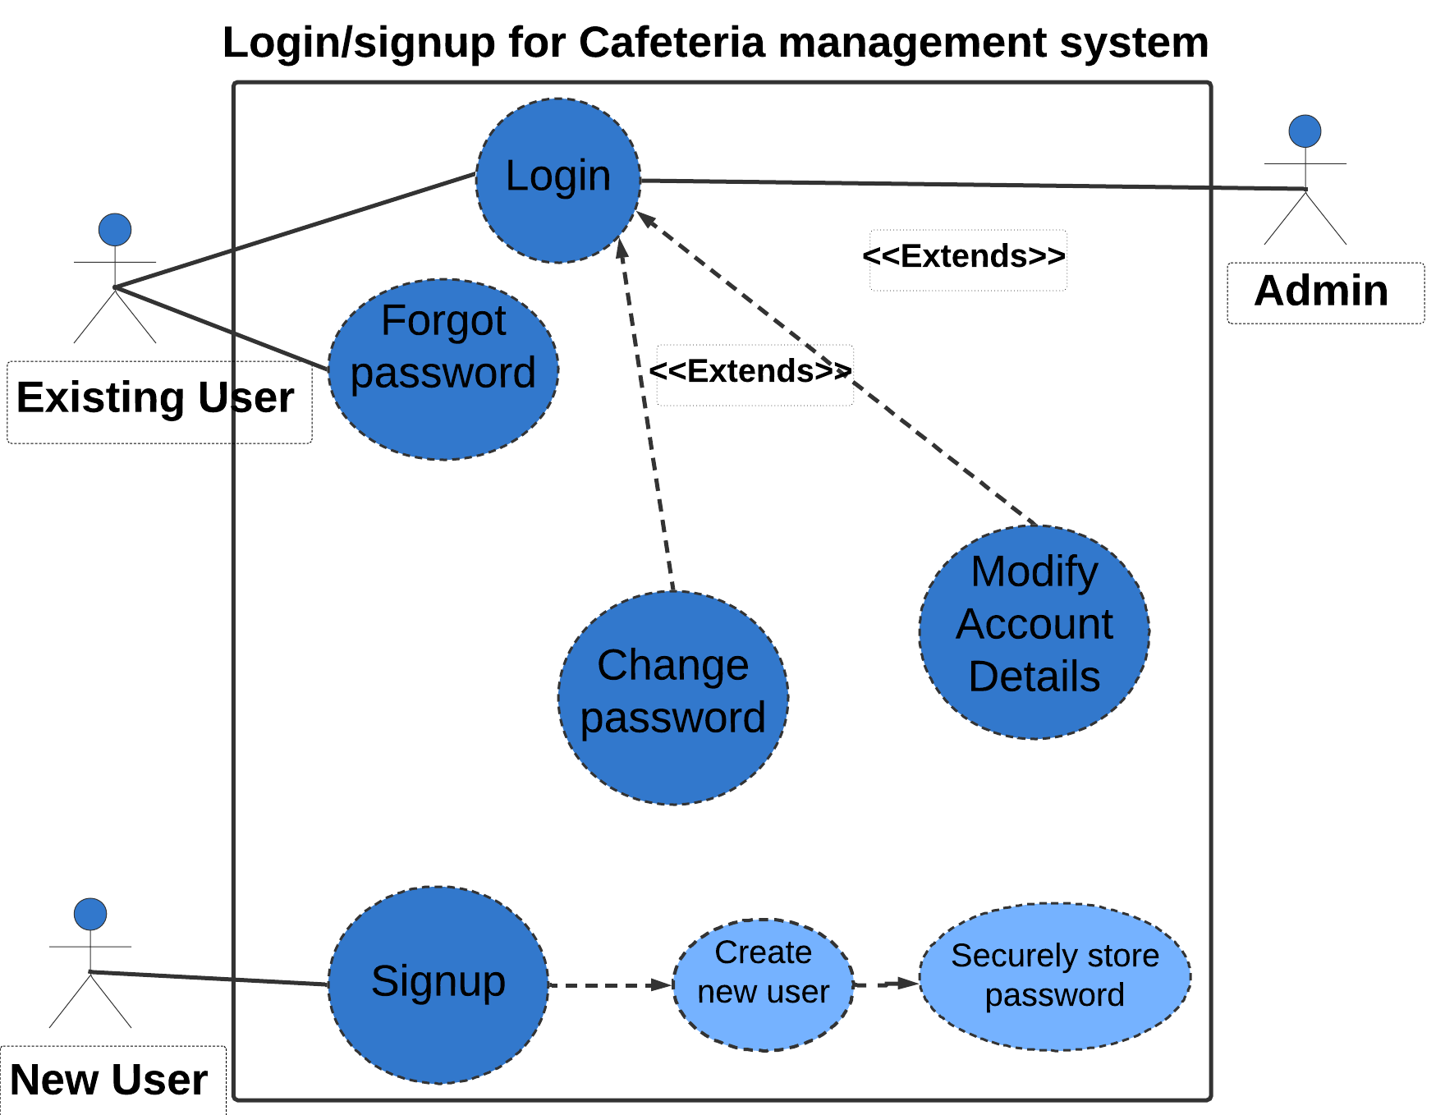

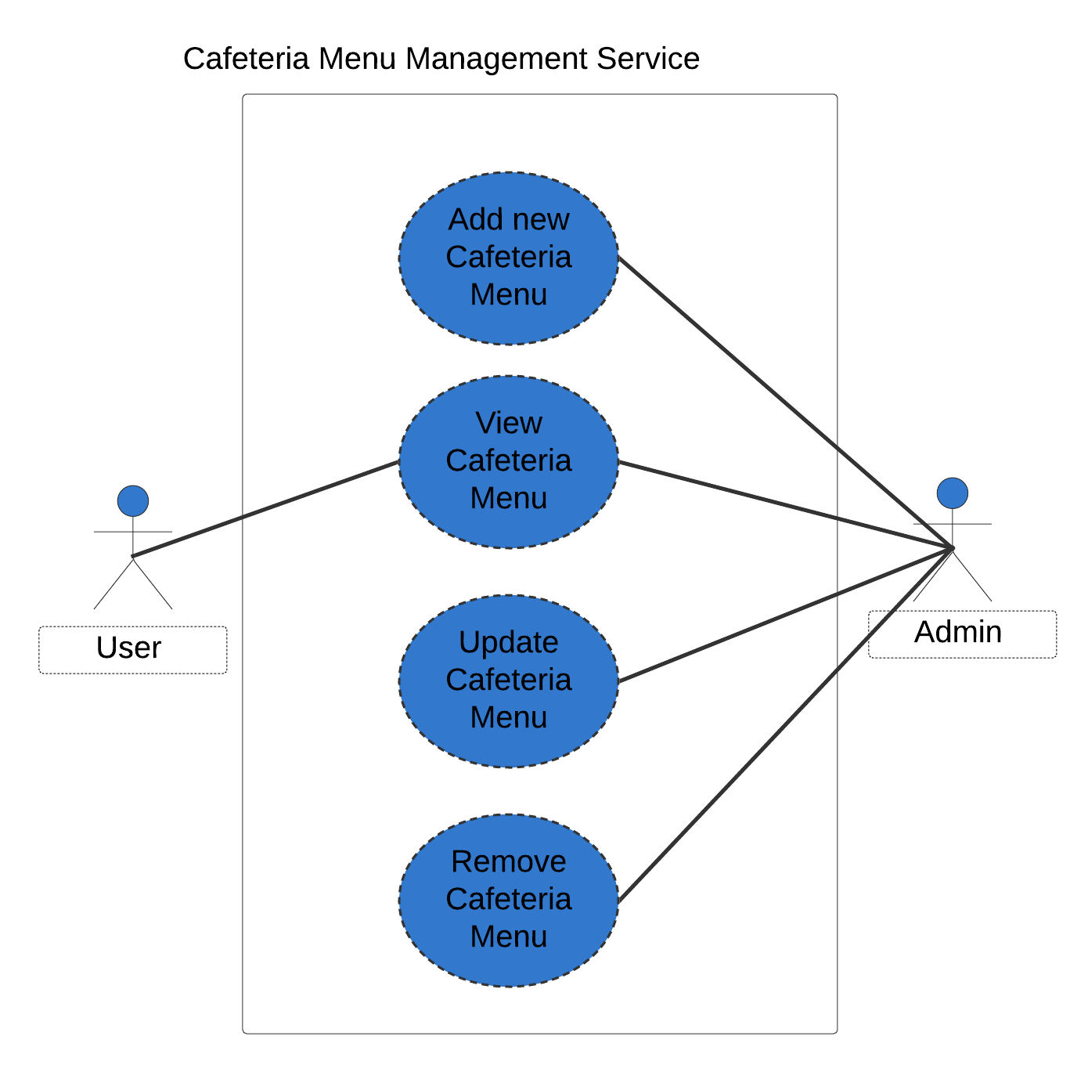

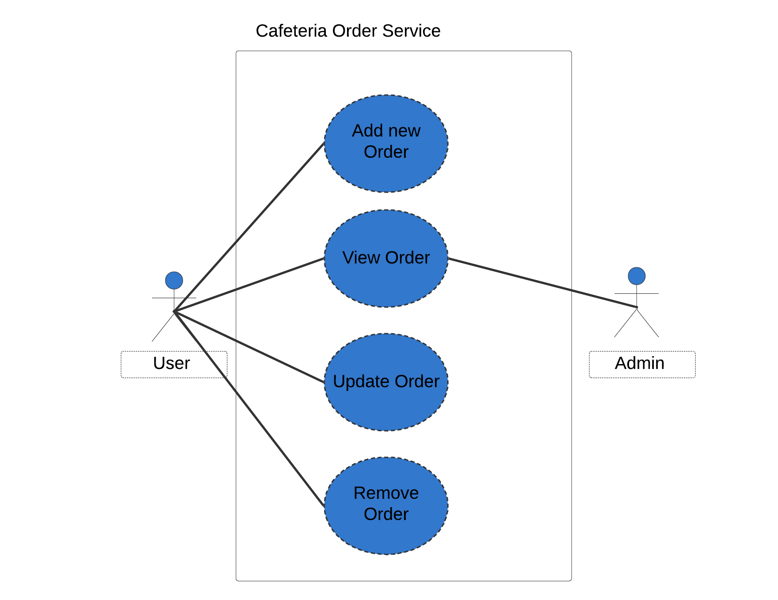

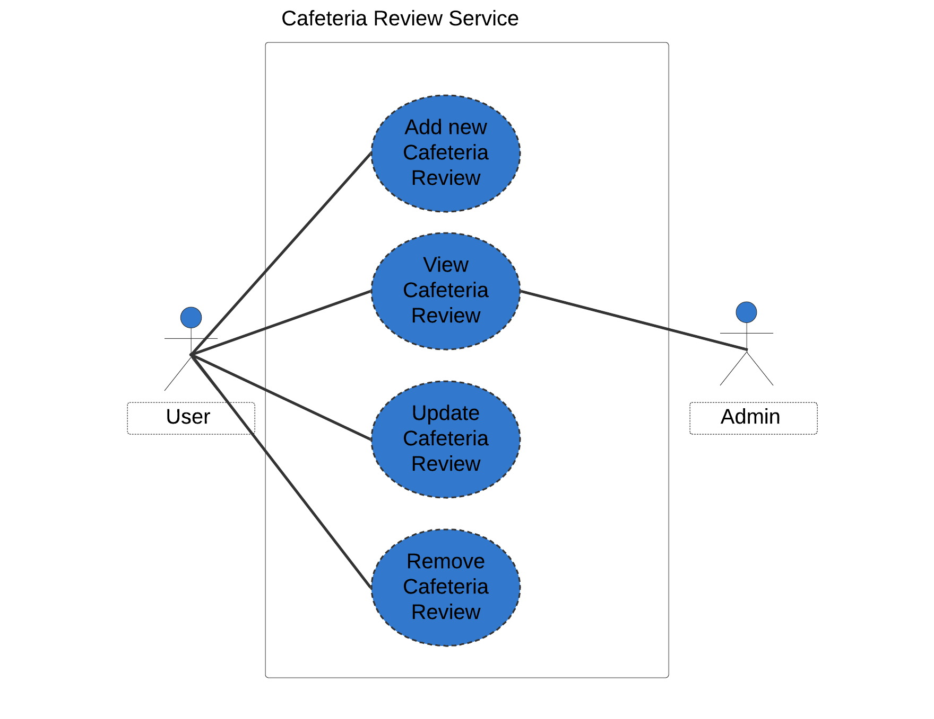

**Class Diagram**

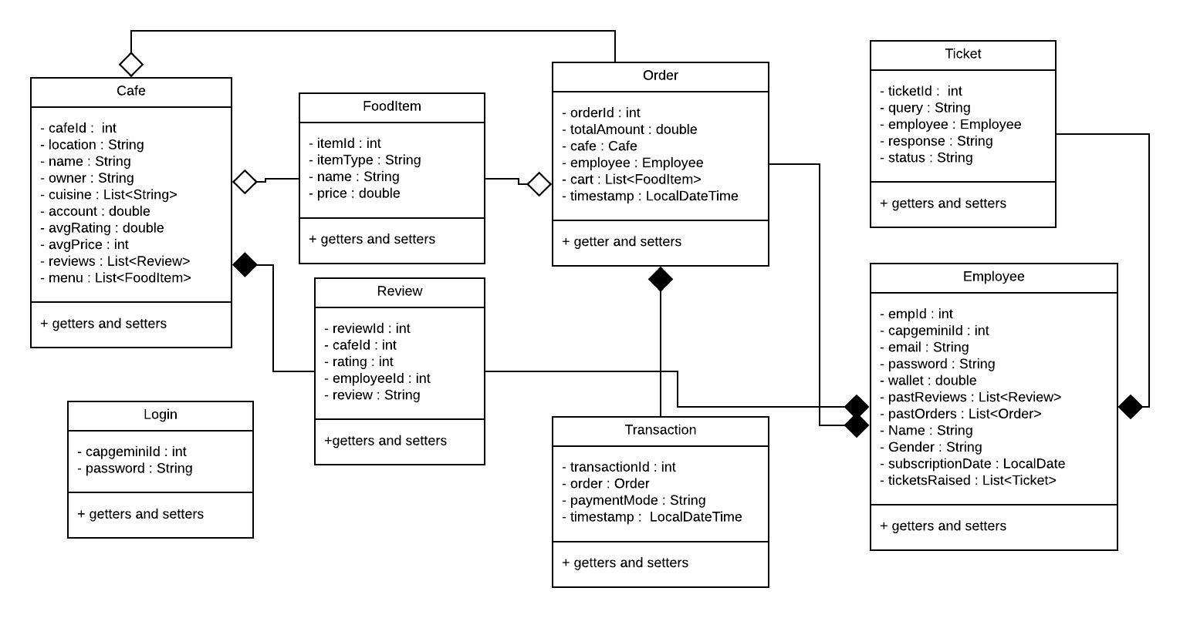

**Sequence Diagram for Login**

**Admin Login:**

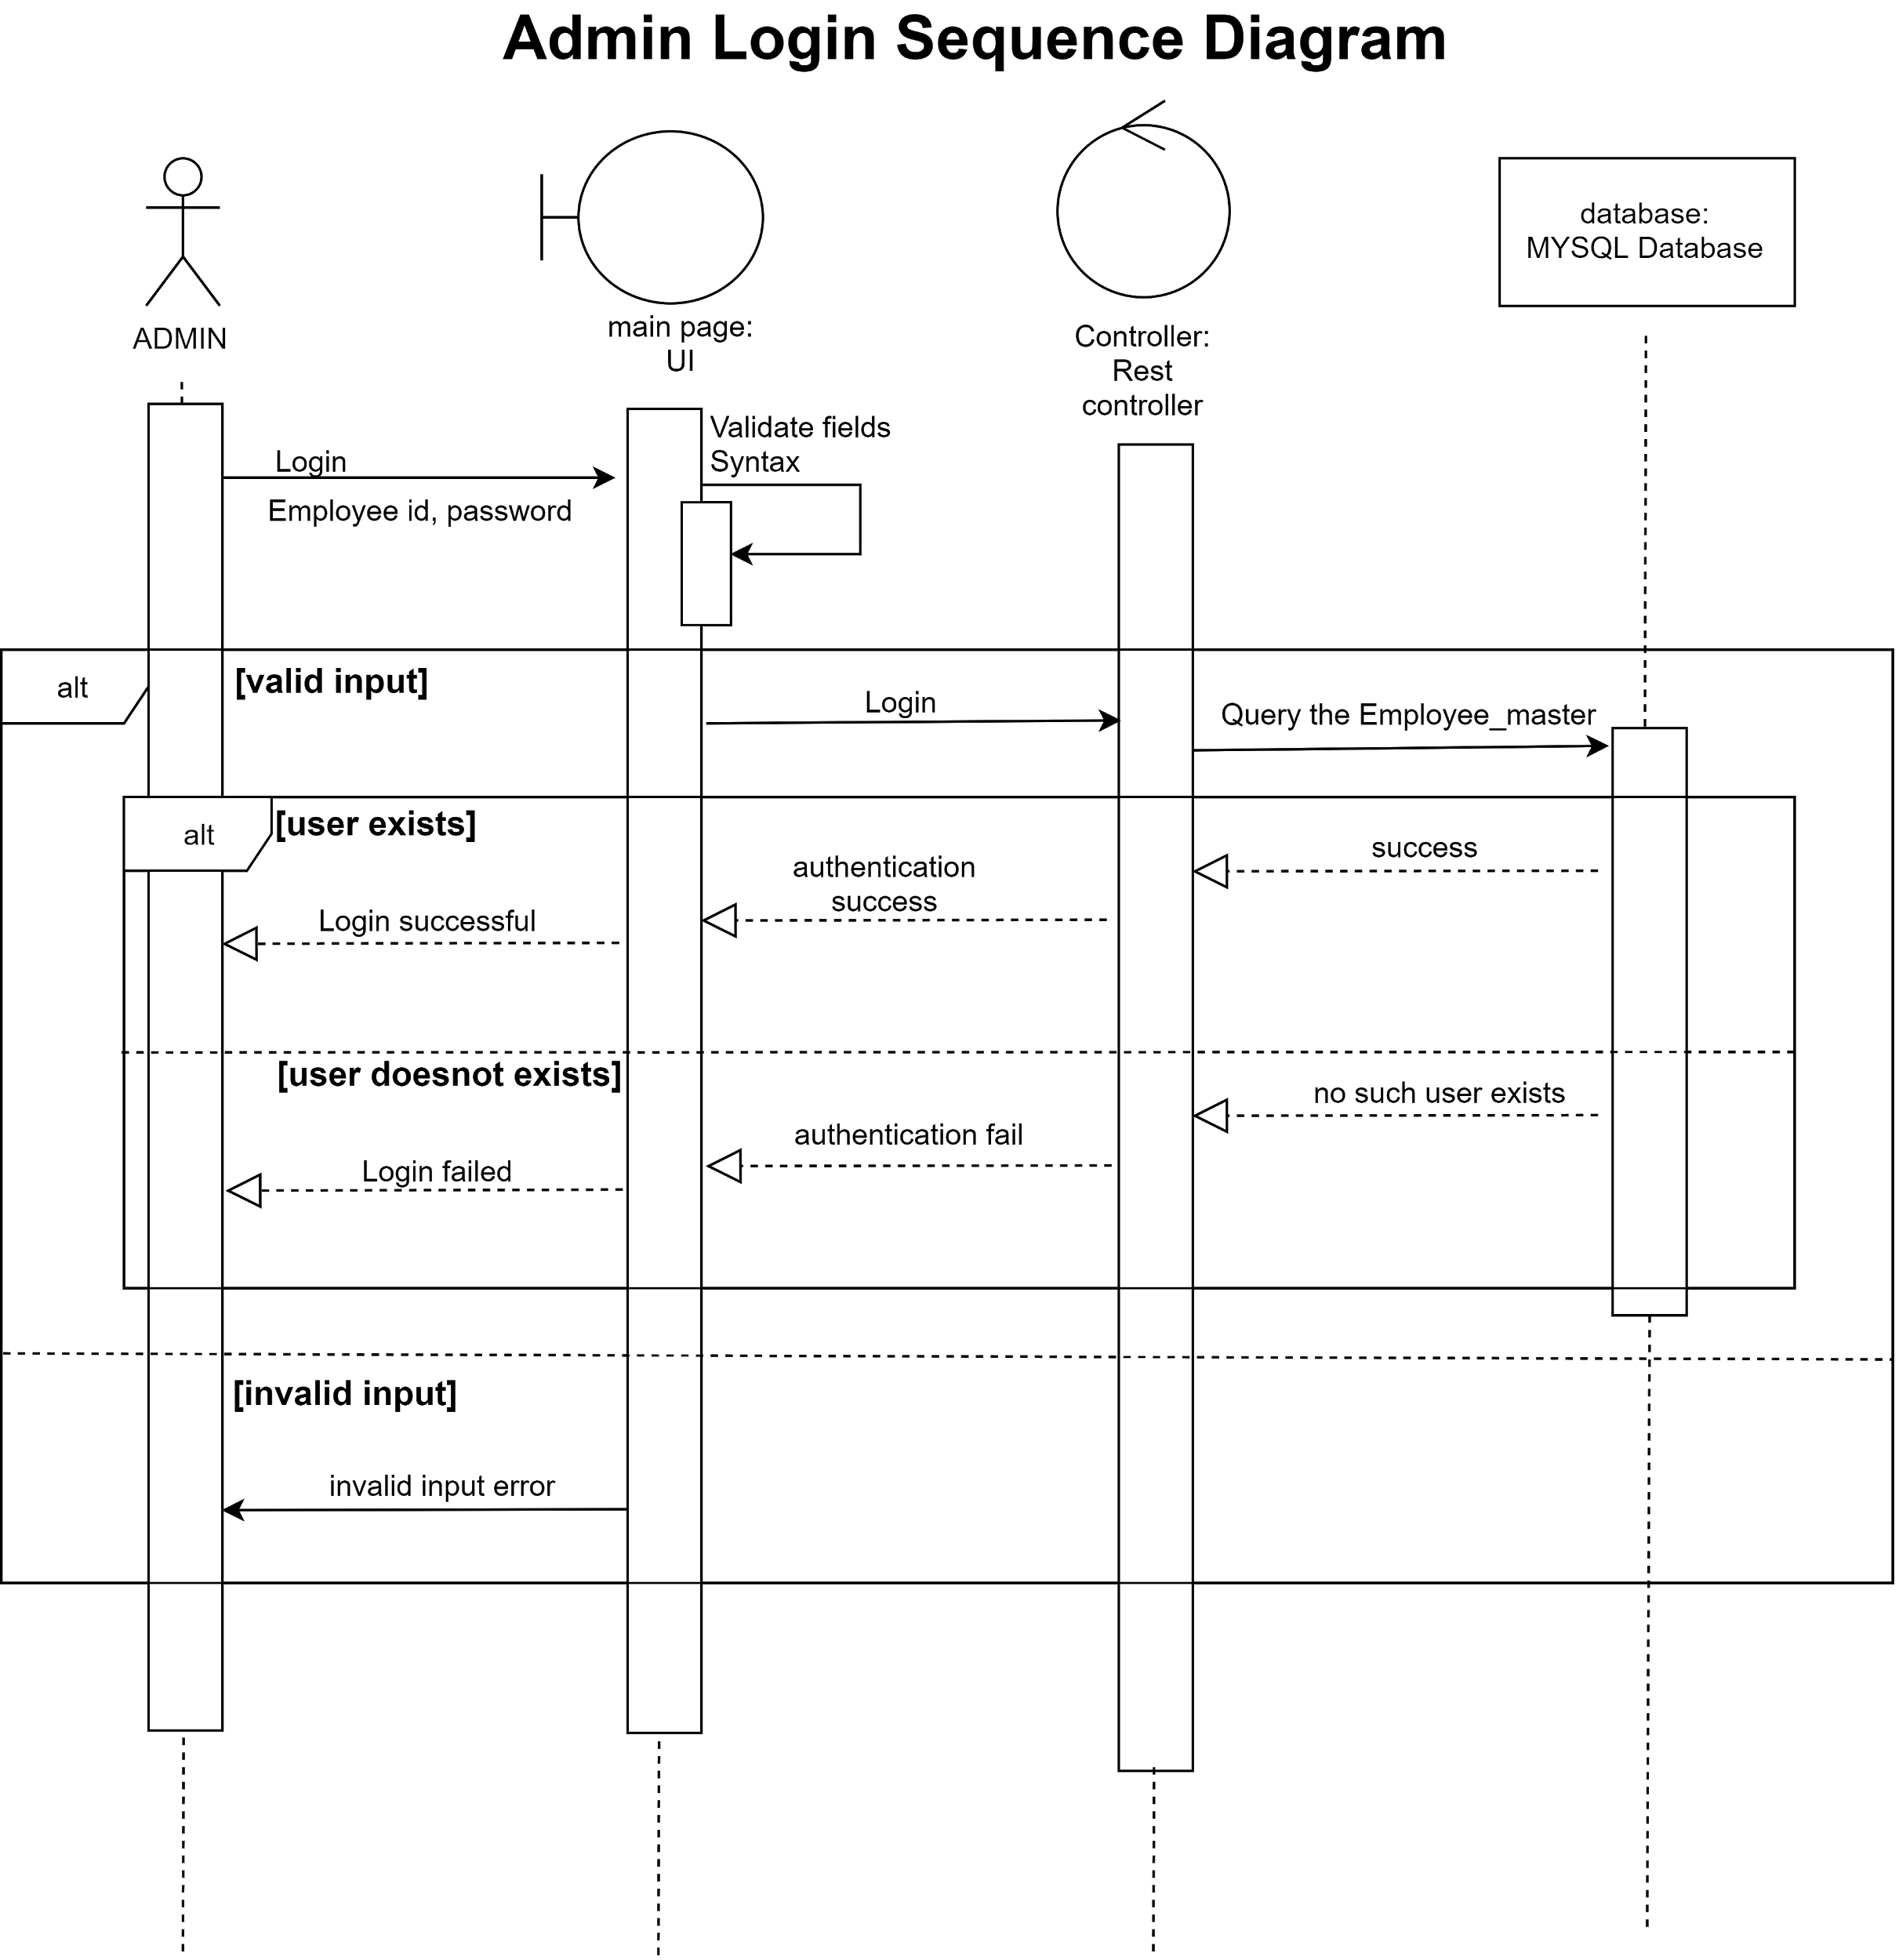

**Employee Login:**

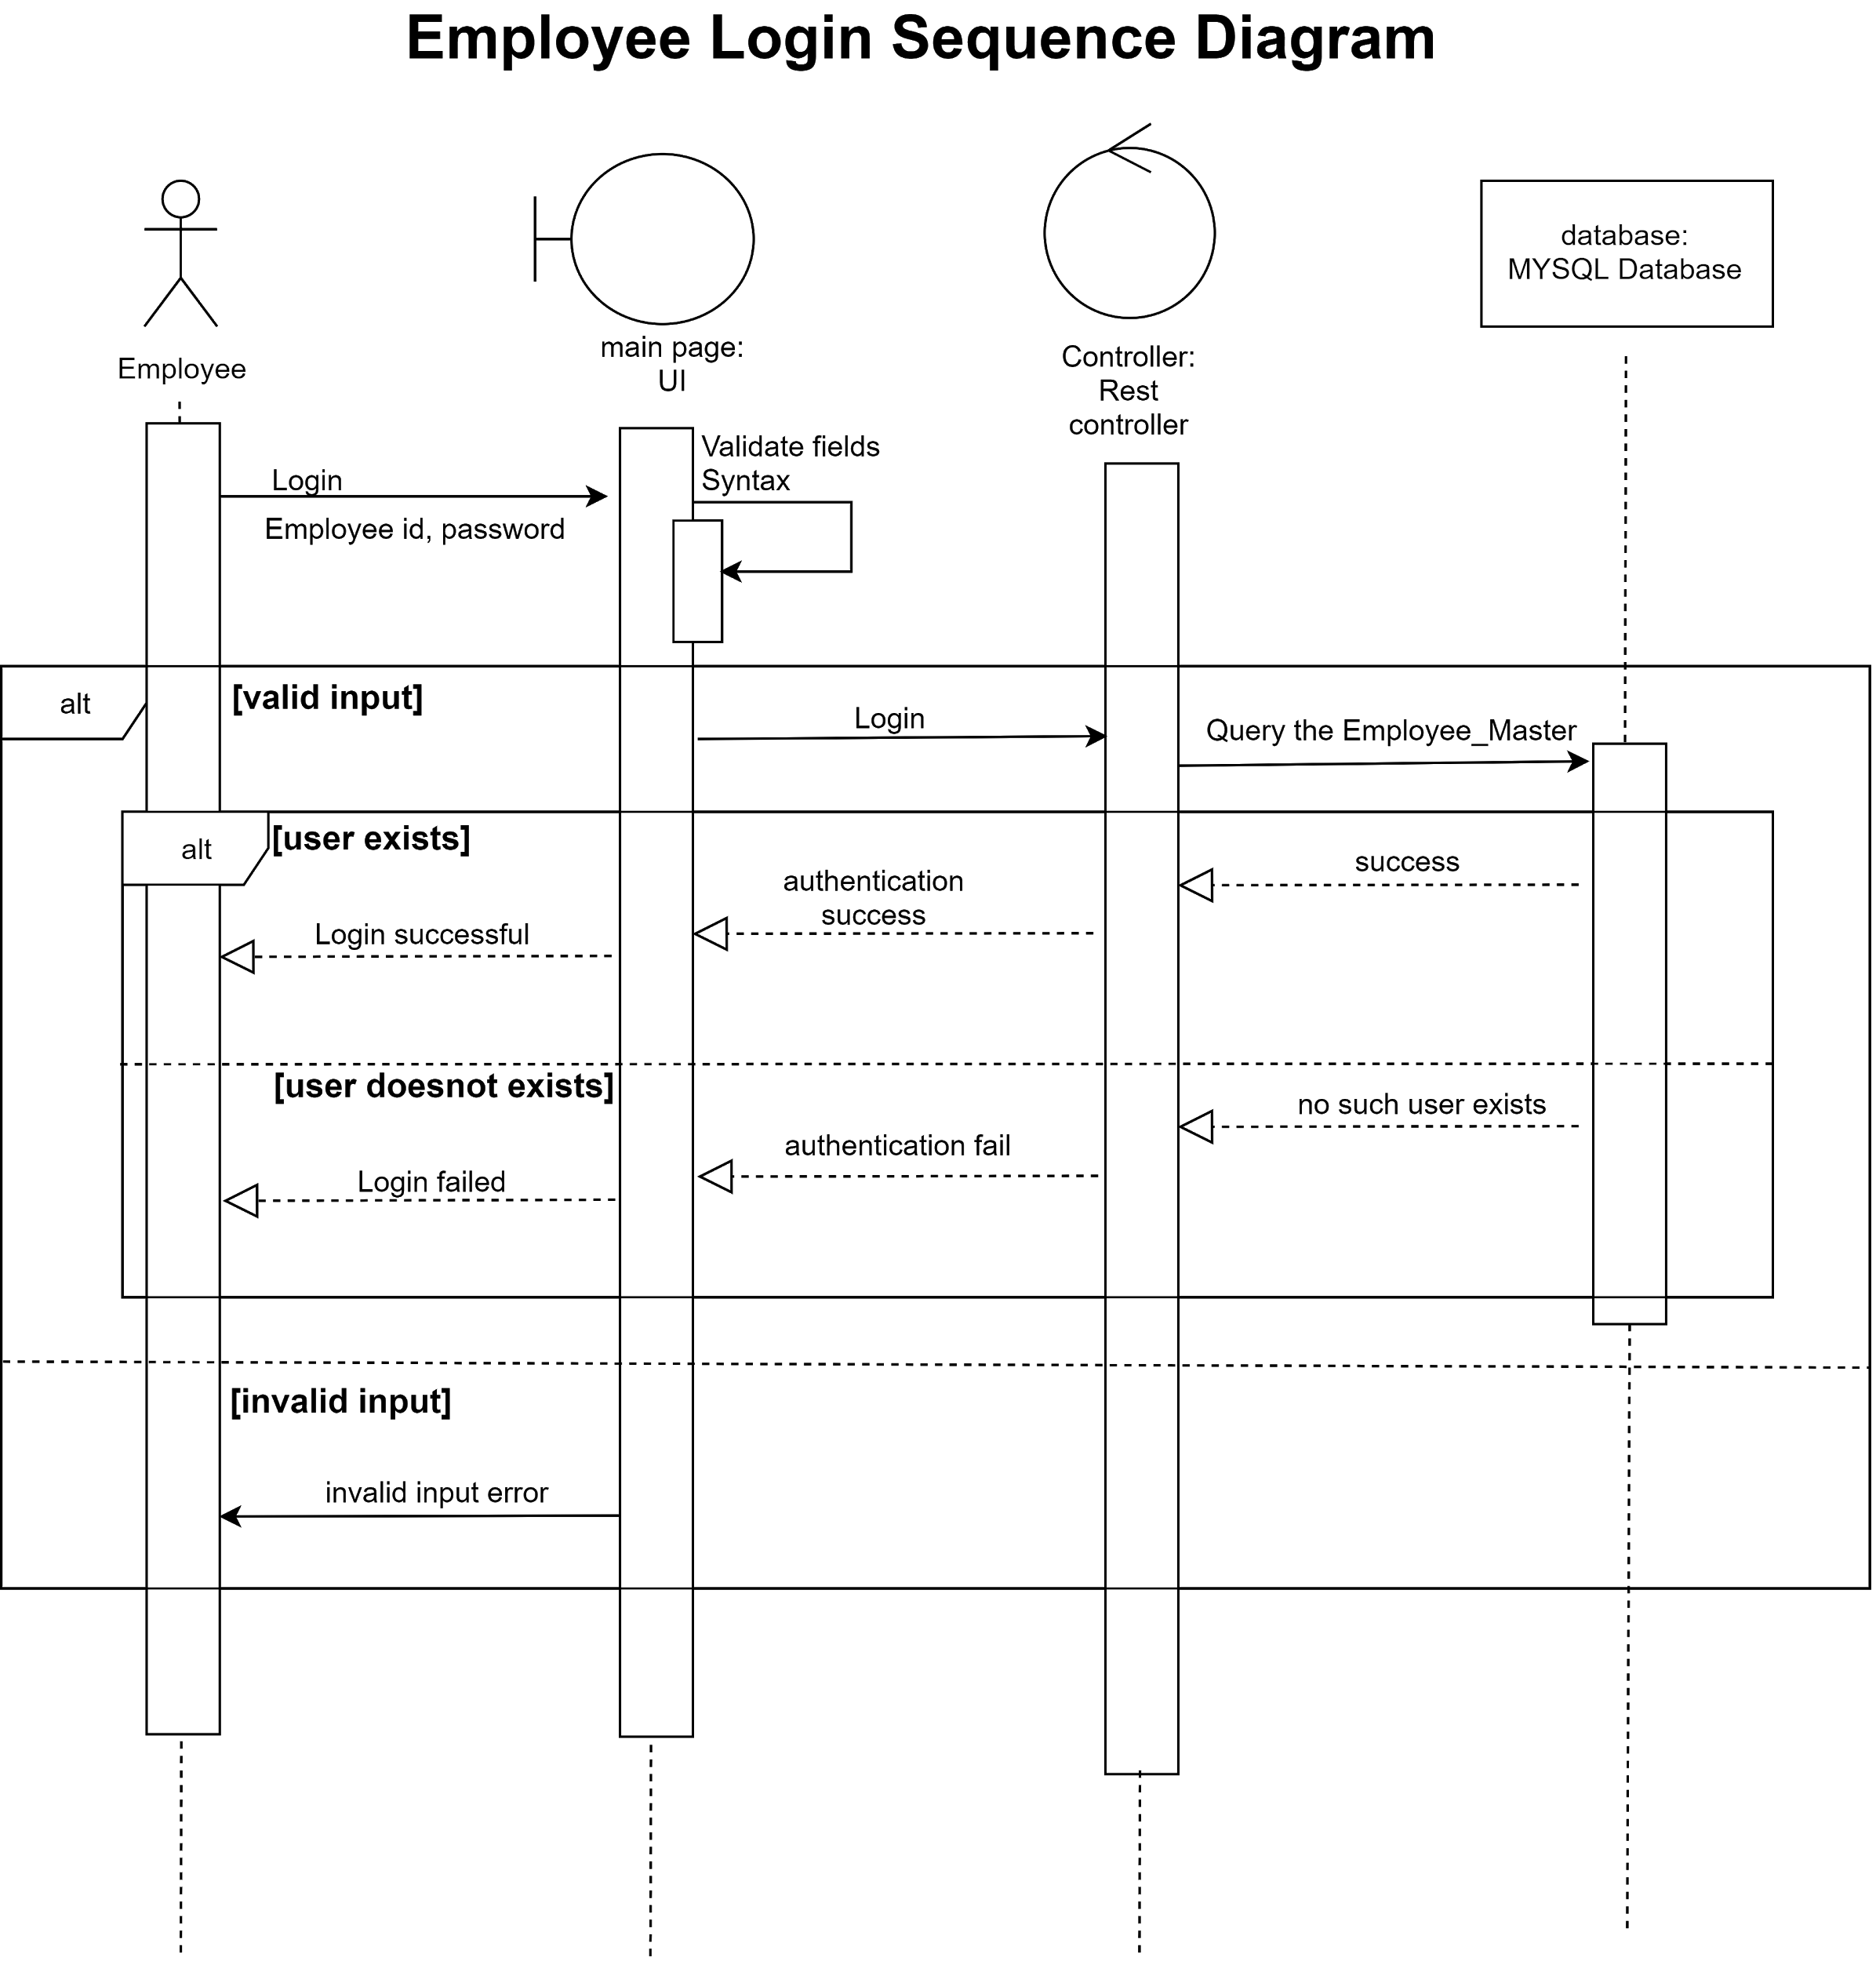

**New Employee Sign Up:**

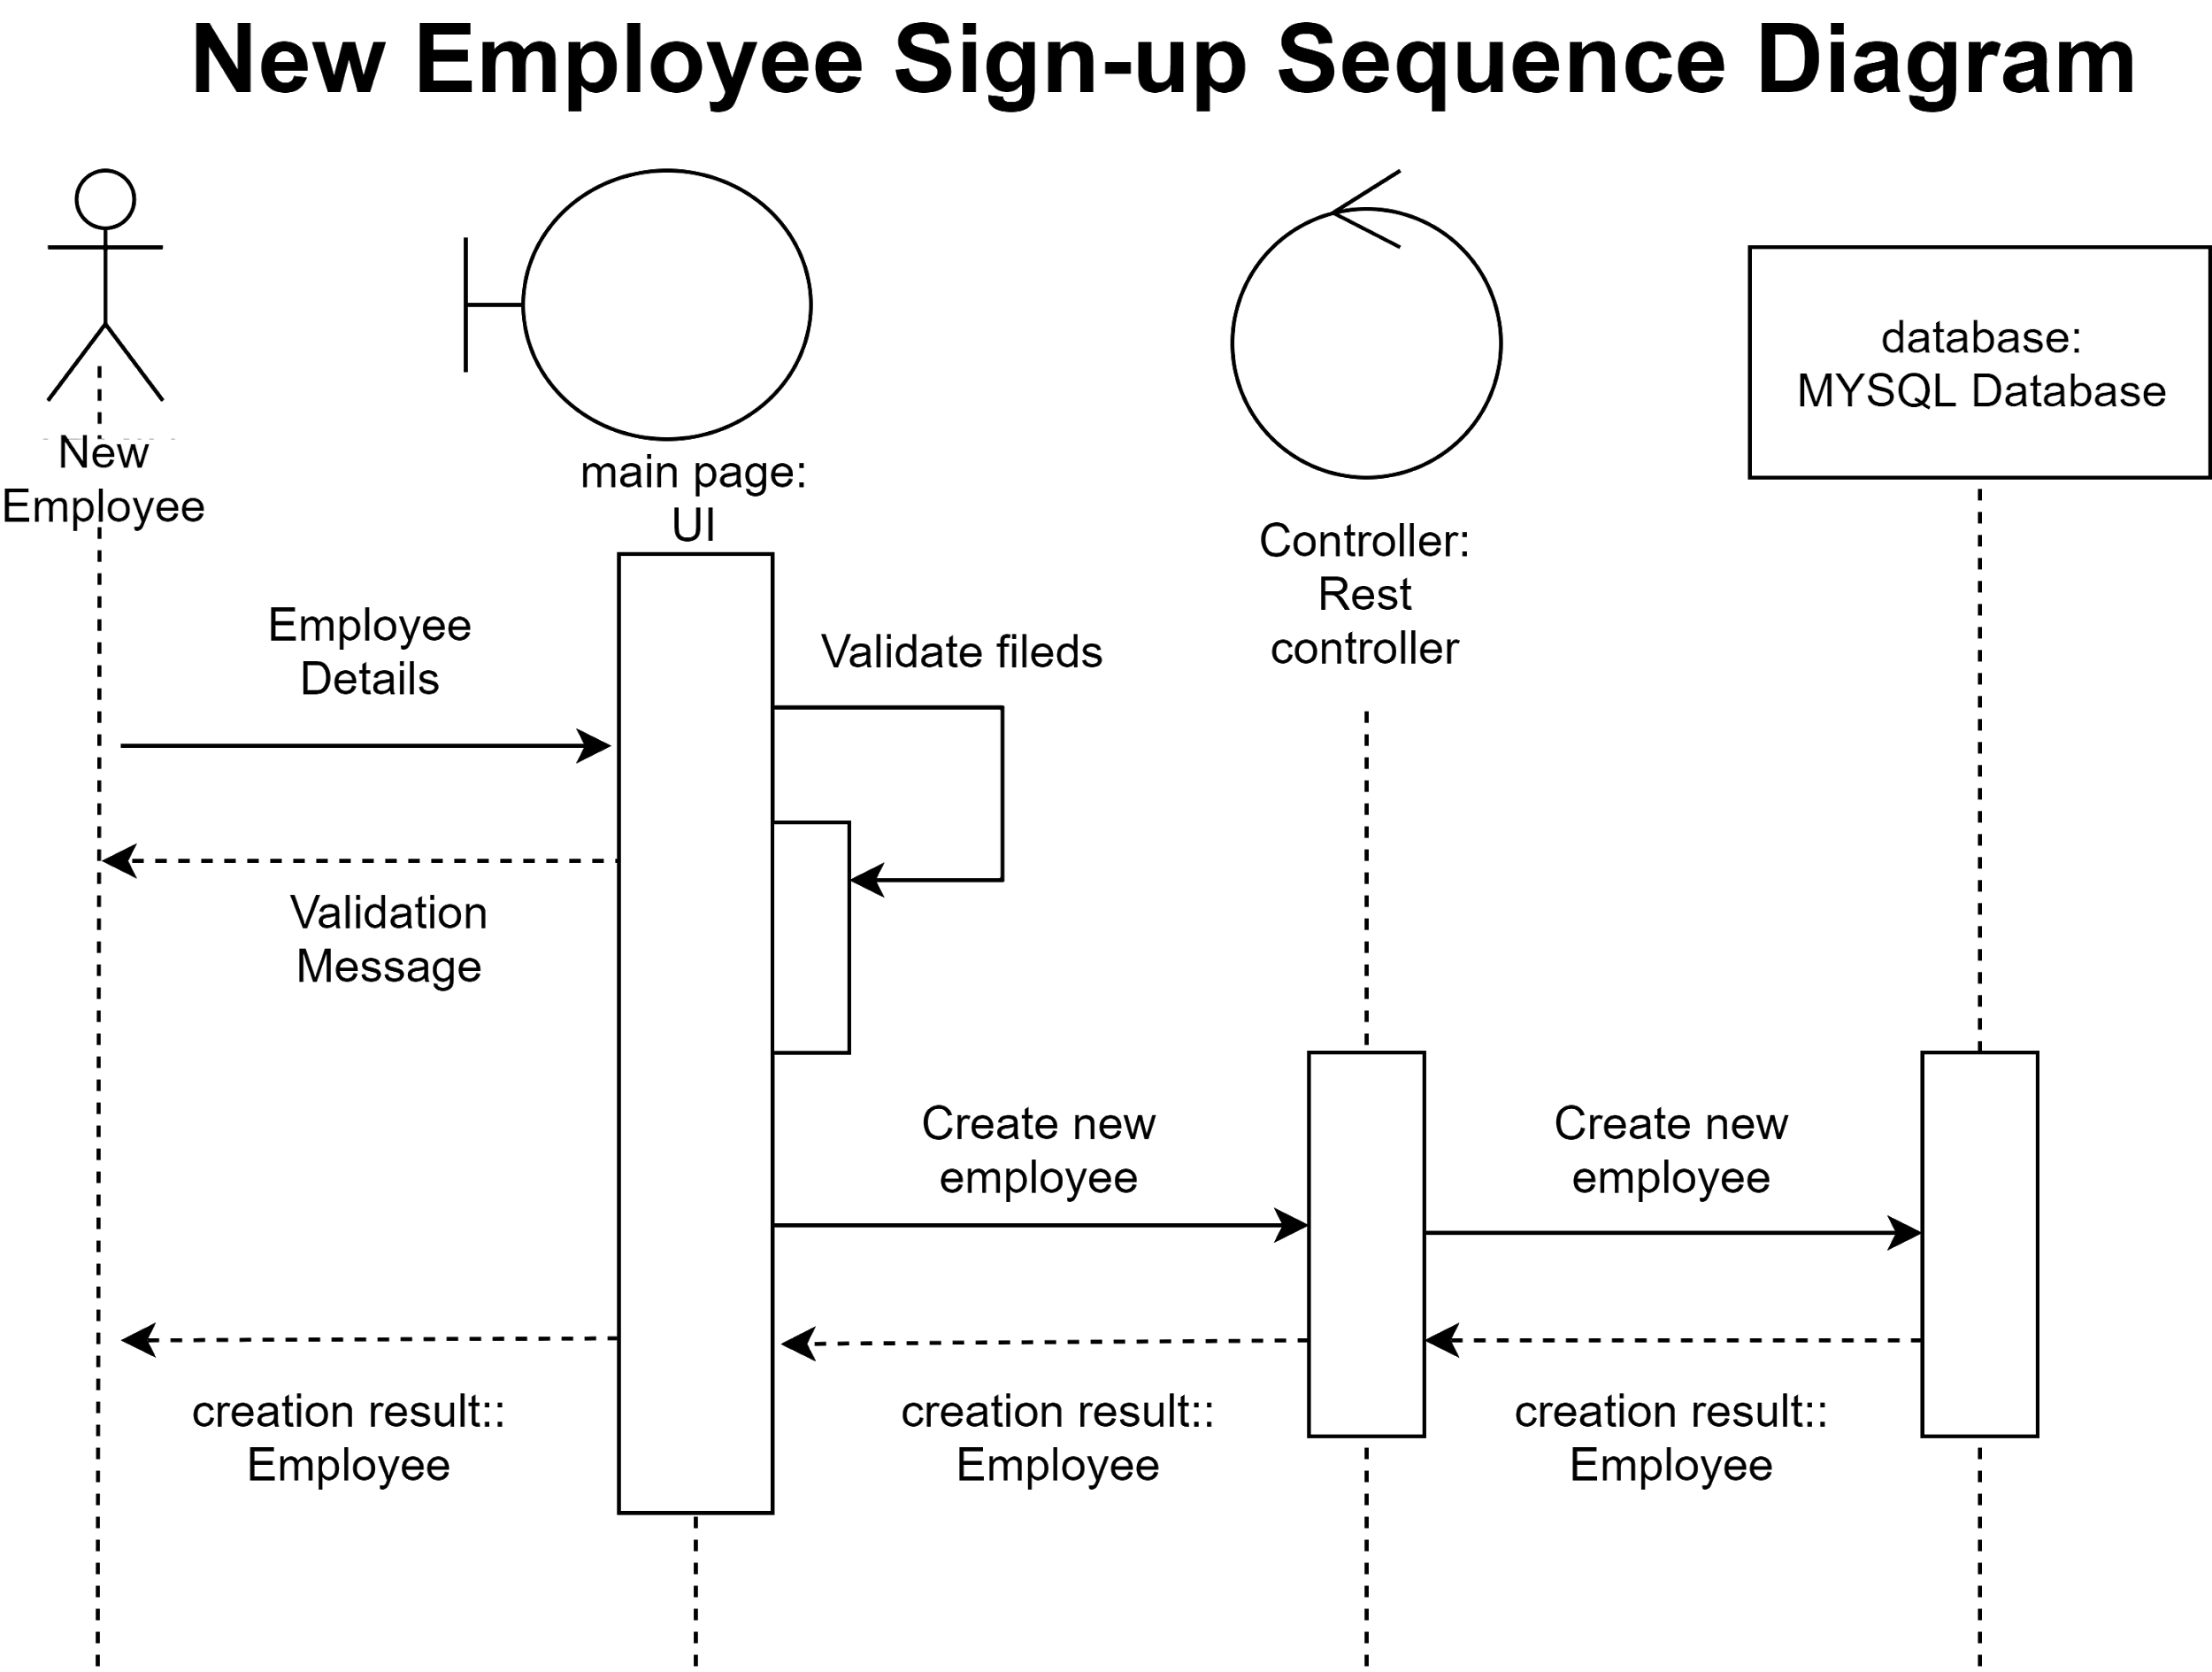

**Cafe Details Sequence Diagram**

**Admin Add Cafe Details:**

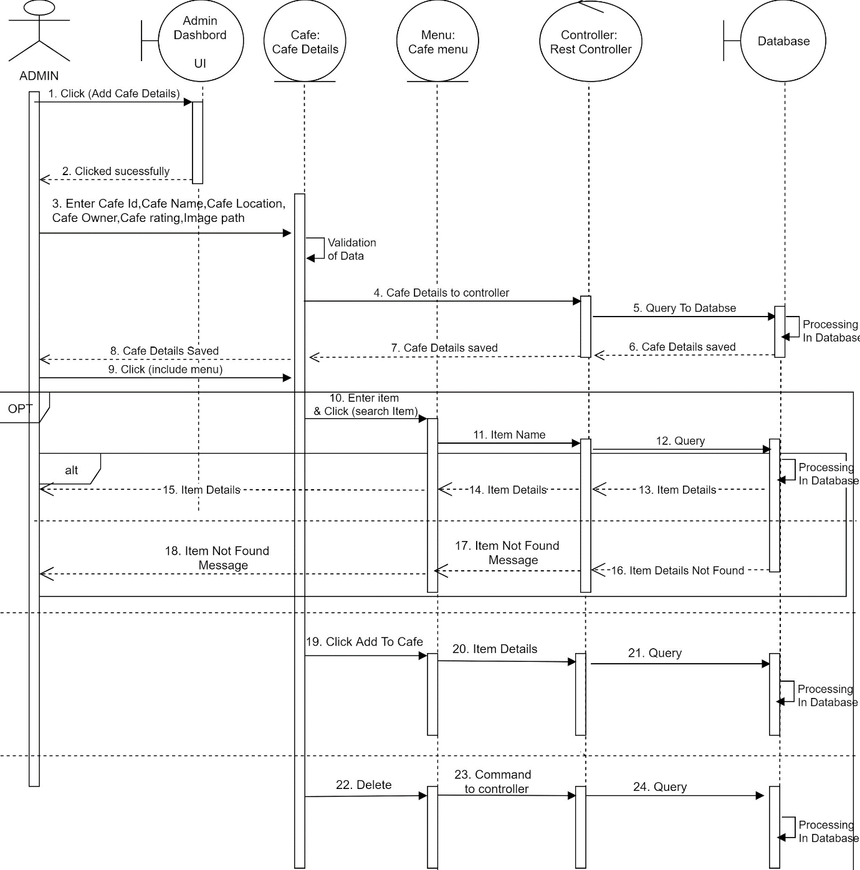

**Flow Diagram**

**User Flow Diagram**

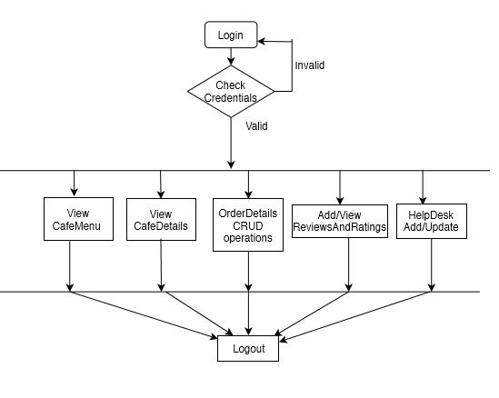

**Admin Flow Diagram**

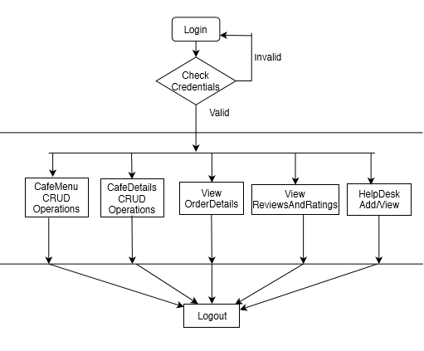

**ER Diagram**

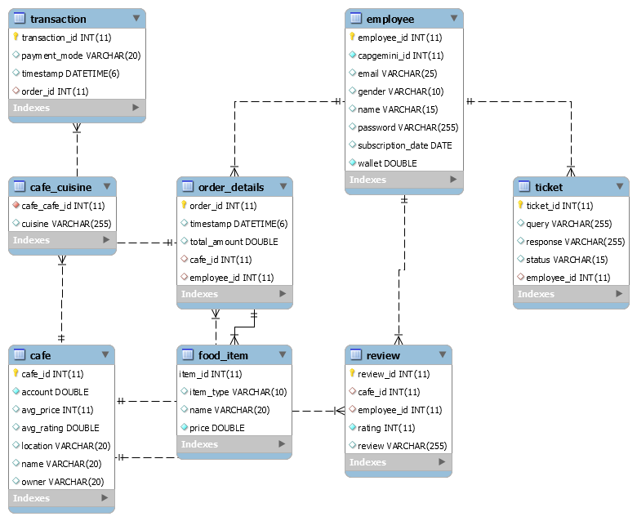

**Activity Diagram**

**User Activity Diagram**



**Admin Activity Diagram**



**Wireframe**

**Home Page**

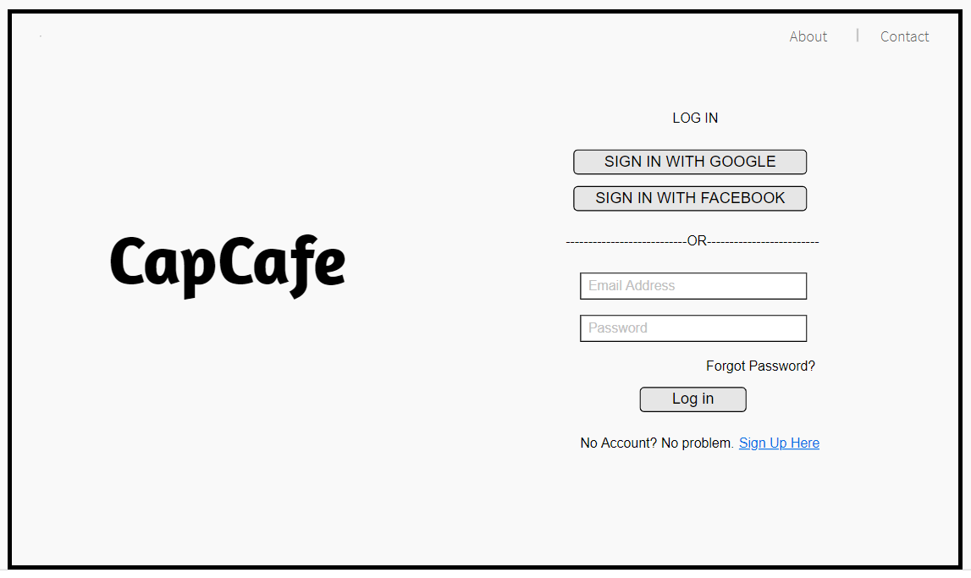

**Sign Up Page**

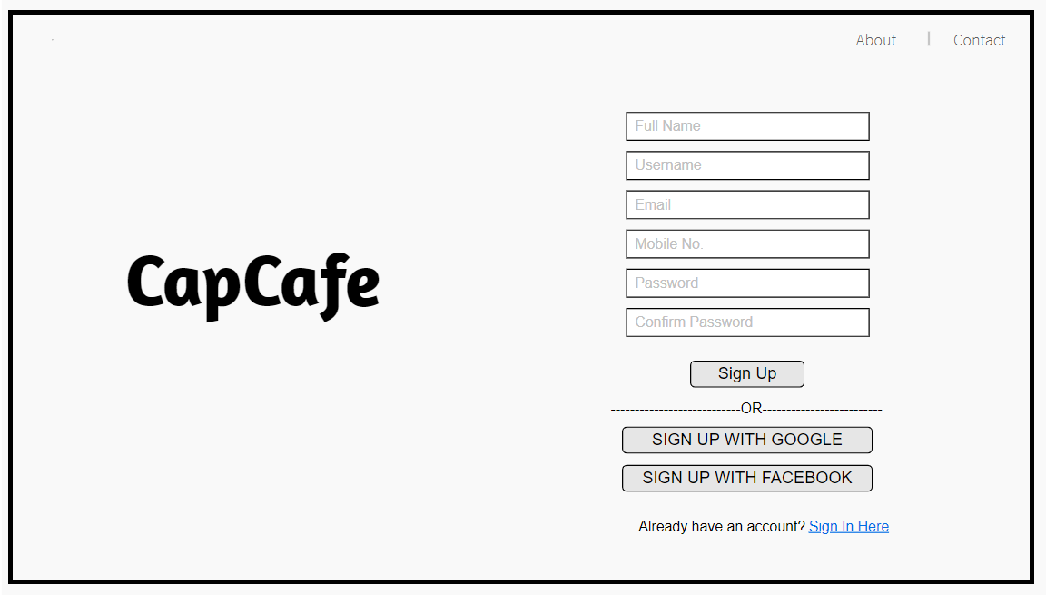

**Employee Login:**

**Café Page**

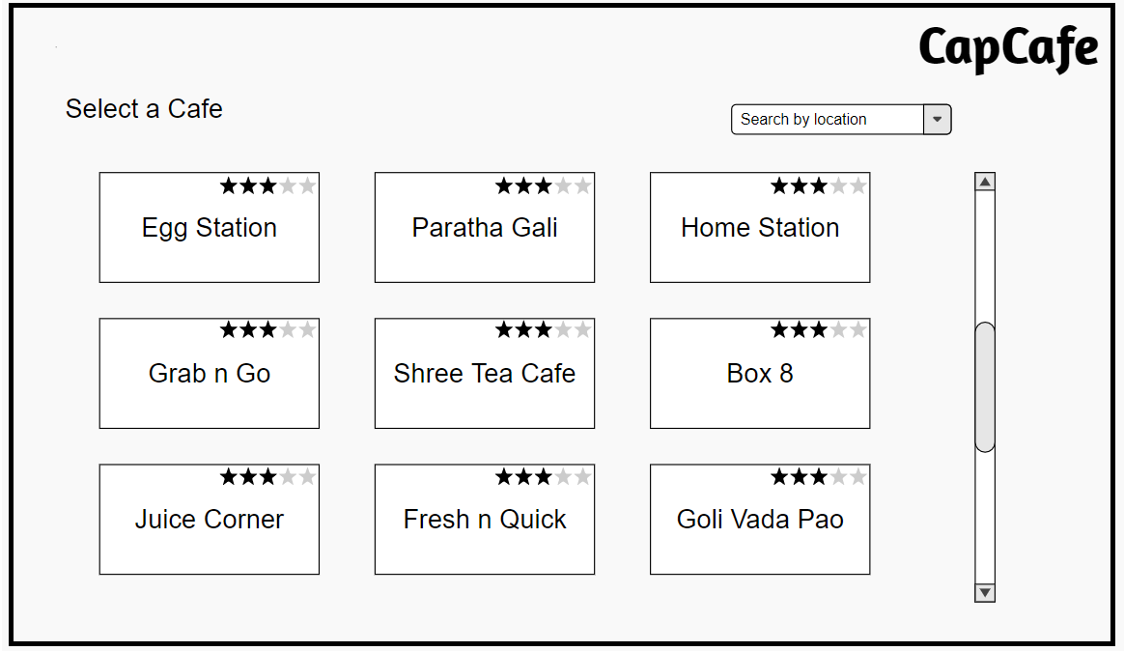

**Menu Page**

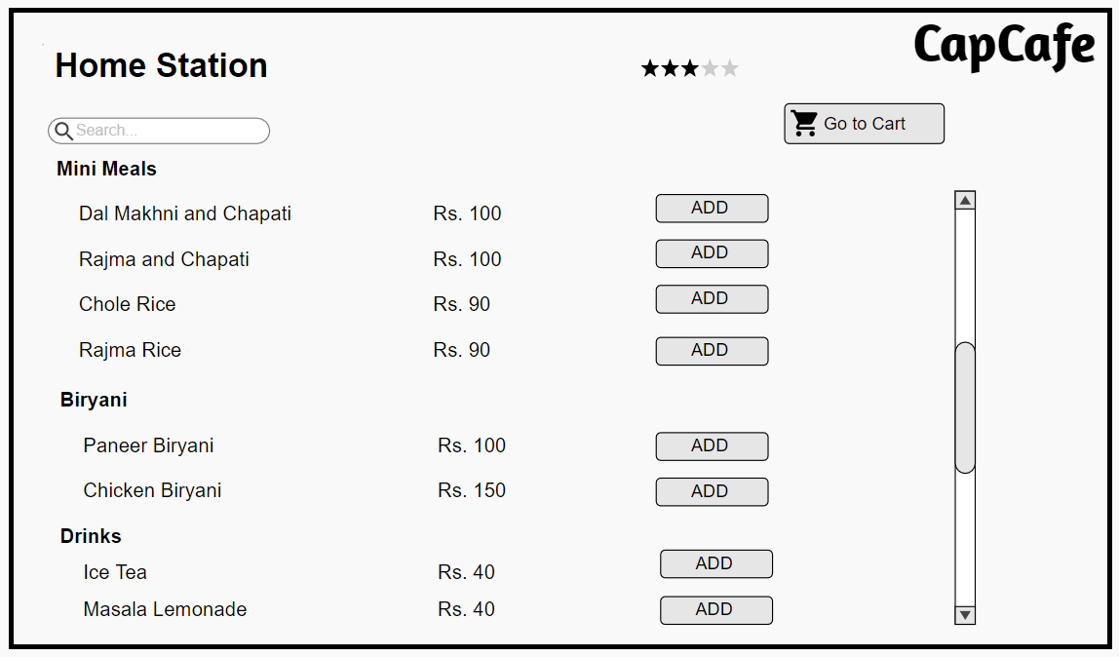

**Cart Page**

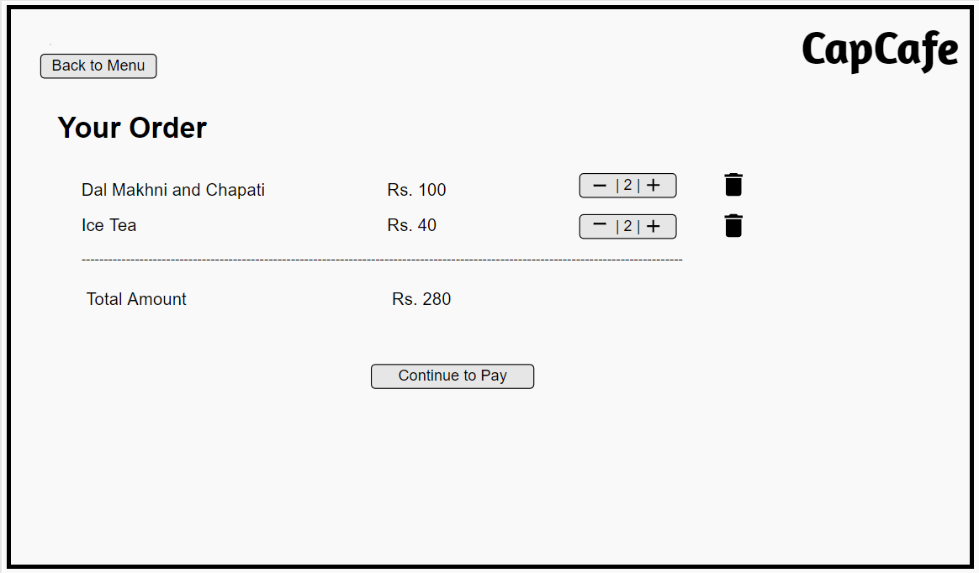

**Payment Page**

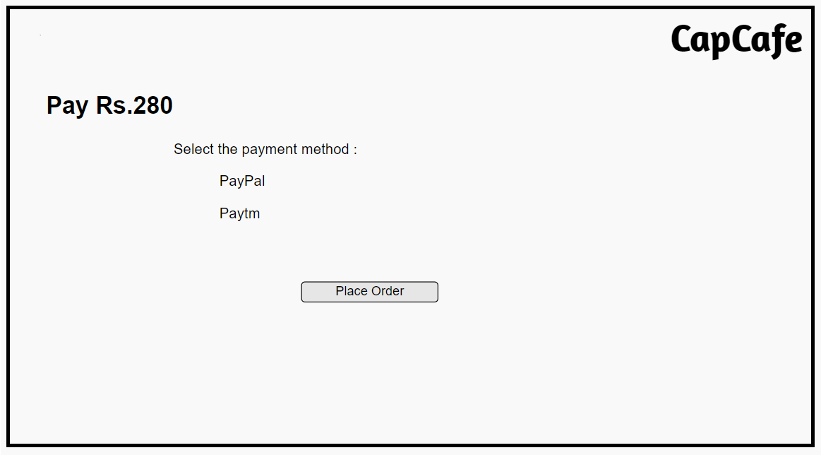

**Order Confirmation Page**

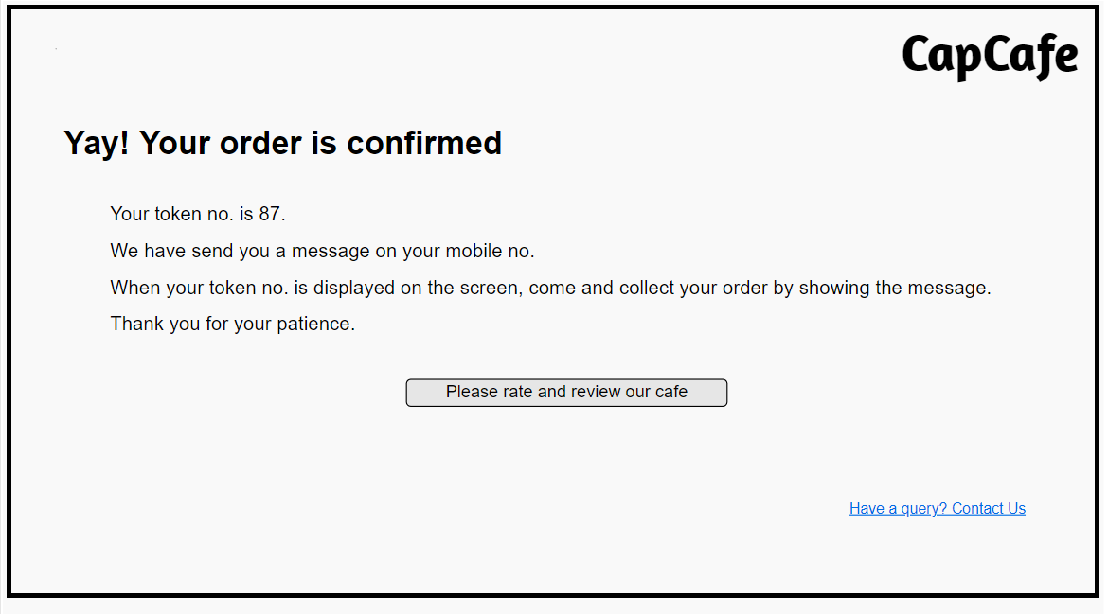

**Review Page**

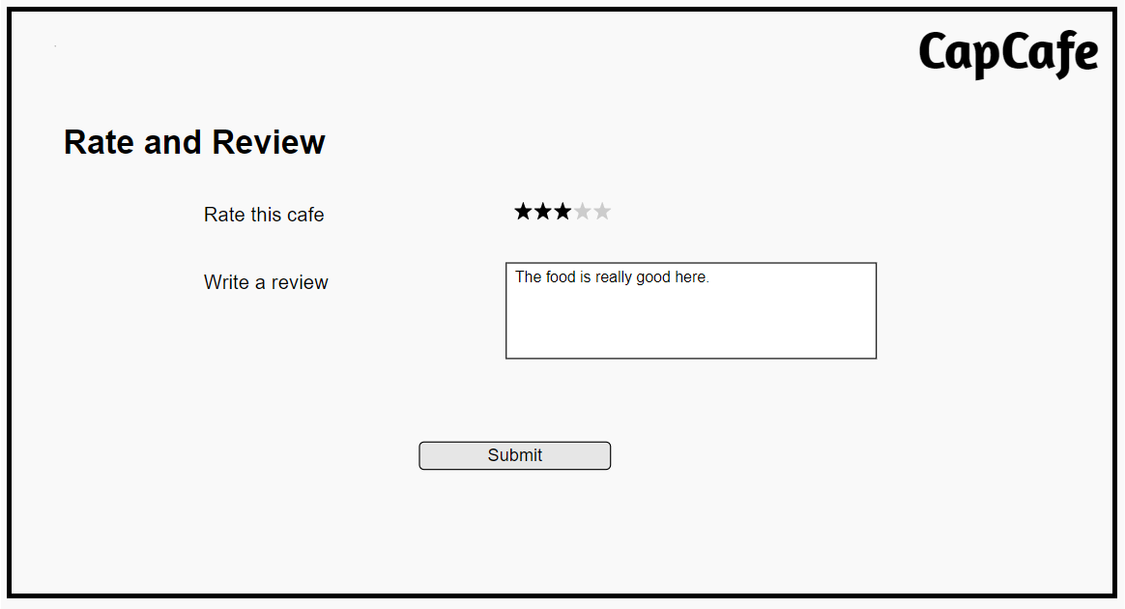

**Help Desk Page**

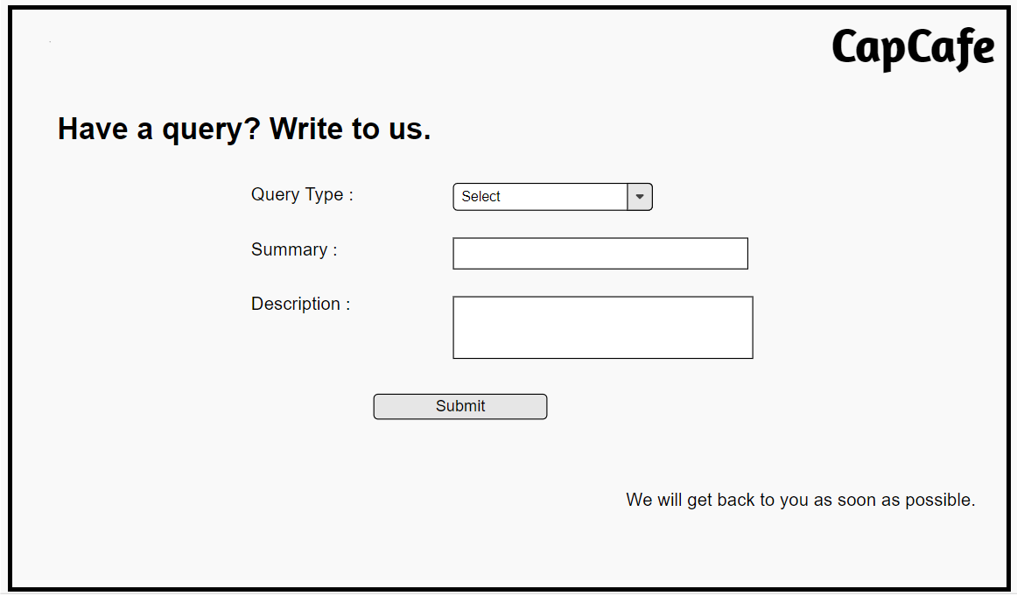

**Admin Login Page**

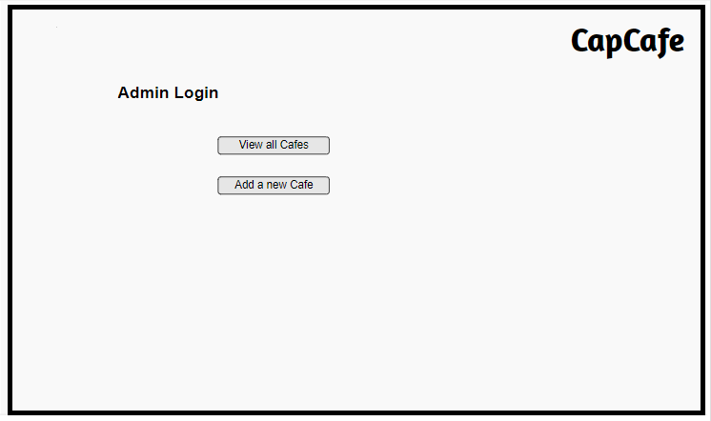

**View all Cafes Page**

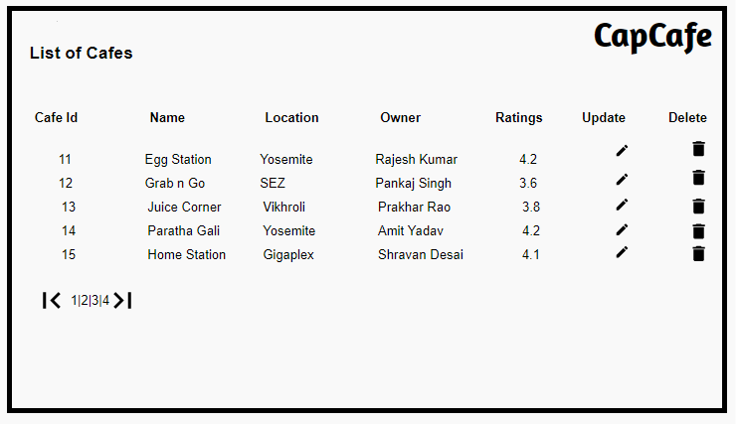

**Functional Modules**

**User Code Module**

1. 1: Signup:

For New Users, they have to first signup/register with the valid UserName, Employee id, password, Contact Number, Mail Id, Security Question and its answer .

· UserName is combination of UperCase alphabets and white spaces (cannot be empty).

· EmployeeId is combination of numbers and alphabets. Should contain exact 6 digits (cannot be empty).

· Password can be any number of charecters (cannot be empty).

· Contact number should be valid Mobile Number beginning with any of digits from 6 to 9 and should be of exact 10 digits (cannot be empty).

· Mail id should be validated with the defined regex pattern (cannot be empty).

· Security question is to be selected from drop down menu.

· Answer of the security question should have atleast 5 charecters.

1.2: Login:

For registered Users, they can Login into the system using registered UserName and Password.

· UserName and password should map with existing username and password in database.

1.3: Recover Password:

In case , User has forgotten his password, he/she can recover it by answering the security question he has answered while registering into the web app.

1.4: Change Password:

In case, the user wants to change his/her existing password, they can change after Logging into the app with their valid credentials. He/She should again set the password according to Password rule defined.

1.4: Logout:

The user can Logout at any point he wants to end the existing session.

**Cafeteria Code Module:**

Cafeteria Admin can add/update/view/delete cafeteria information in this module. Employee can view Cafeteria details

1.1: Add new Cafeteria:

· Cafeteria Id will be auto generated and should be of 4 digits.

· Cafeteria Location should begin with Capital letter and should be a valid location having only characters.

· Cafeteria Menu can contain any specified food item.

1.2: Update existing Cafeteria:

· Cafeteria Location and it’s menu can be updated using existing Cafeteria Id according to defined validation rules.

1.3: Remove existing Cafeteria:

· Any existing cafeteria can be removed from the app by admin using existing cafeteria Id.

1.4: View existing Cafeteria :

· Any existing cafeteria details can be viewed by Admin/User by fetching criteria like fetching through Id and Location.

**Menu Code Module:**

Cafeteria Admin can add/update/view/delete cafeteria menu in this module. User can view Menu details. User only has privilege to view menu according to specified cafeteria location.

1.1: Add Menu details:

Menu Details will be added according to the respective cafeteria Location.

· Item Id will be autogenerated.

· Cafeteria Id needs to be specified for which menu details are added. Provided Cafeteria Id should match with existing cafeteria Id.

· Price of item should be valid numeric entry.

· Type of food item should contain characters only.

1.2: Remove Items Menu:

· Any existing food item from Menu can be removed using existing item id and cafeteria id.

1.3: Update Menu Details:

Any existing menu details can be updated.

· Item type can be updated using Item Id and its Cafeteria Id.

· Item price can be updated using Item Id and its Cafeteria Id.

1.4: View Menu Details:

· Menu Item details can be fetched using its item id and cafeteria id.

· All item details in menu can be viewed using cafeteria id it belongs to.

· Menu details can be viewed by user using Location attribute of Cafeteria.

**Order Code Module:**

User can place and view his order from menu. Admin can view all the placed orders.

1.1: Place Order:

User can place order.

· Order Id will be auto generated.

· Quantity option is provided through a dropdown menu.

· Items should be selected from menu.

· Payment type should be mentioned by user. Options are provided using drop down menu.

1.2: View Order:

· User can view any of his placed order using order Id.

· User can view all of his placed orders.

· Admin can view orders according to user id, specified date.

1.3 Filter Order:

· Admin can view orders filtered by any particular item id.

· Admin can view orders according to specified price range.

**Feedback Code Module:**

User can add/view review and rating for Cafeteria service. User can also add/view rating and review for particular item in a menu of specified Cafeteria. Admin can only view all the reviews and ratings.

1.1: Add review and rating:

· Review/Comment can be combination of alphanumeric characters. Review should not exceed more than 200 characters.

· Rating should be anywhere between 1-5.

1.2: View review and rating:

· User can view all ratings according to specified cafeteria and item from a specific Cafe.

· Admin can view all the reviews and ratings according to the selected Cafe Name.

**Helpdesk Code Module:**

Admin can perform view operation on raised tokens for particular order and send response messages for complaint tokens raised by user. User can perform create/delete operation on raised tokens for particular order and send response messages for complaint tokens raised by user.

1.1 Raise a query

User can raise a query on an order

· Order ID is self-generated foreign key from orders

· Request will be a character string

1.2 View Unresolved Queries

Admin can view all the queries which are unresolved raised by users

1.3 View Resolved Queries

Admin can view all the unresolved queries raised by users

User can view responded query

1.4 Resolve Query

Admin can resolve queries whose status is unresolved